Lecture 1:
1. What is AI?
Write in one sentence using your own words: What is AI?
Human-made computer systems/software that have been through extensive algorithms and training to imitate human intelligence.
2. AI Examples
Write down one thing that you believe AI will never be able to do and why:
I believe that AI will never be able to recreate the same level of art as humans, art to me is very emotion based and AI just does not have the capacity to feel the same feelings as humans and thus create art that invokes certain emotions.
3. AI Scavenger Hunt
During one normal day, list 5 moments AI touched your life (suggestions, autocomplete, navigation, filters, spam, recommendations, translation, etc.). For each moment, write:
- What the AI did
- What data it probably used

1. Recommended social media content/Advertisements.
What the AI did: It started showing me posts/advertisements based on what I’ve liked a few video’s prior to these posts popping up. For example I liked a cat video and then my next 10 video’s are all somehow cat related.
What data it probably used: Probably used algorithms based on my data
2. Googling
What the AI did: When I google something it pops up with an AI overview with information about the thing I tried to google.
What data it probably used: Probably used the first dozen or so information sources it could find itself when googling this and compiled the most important things about the topic.
3. Studying/workflows
What the AI did: It made several mock exams for me based on the information, slides and presentations that I gave to it.
What data it probably used: Well, the information I provided to it and then probably searched its own database for similar topics/information to add onto the information I already gave it.
4. AI Pinterest posts
What the AI did: It just generated AI pictures that someone posts on Pinterest which I do not like
What data it probably used: To generate the images it used the likeness, style and artwork of several other artists to make an own ‘artpiece’.
5. Youtube auto-dubbing video’s
What the AI does: It automatically starts translating/dubbing video’s in another language to the language you set it as. (In my case this would be English)
What data it probably uses: No clue
4. Self experiment with AI (30 min):
Chosen AI: Gemini
1. Ask it to explain who you are based only on your name. Note what it gets right/wrong
What it got right: It said I have a strong need for personal creative space, I value authenticity and that I possess an eye for detail and aesthetics. For my hobbies it got it mostly right, I do enjoy art and creating things myself. And I love low-pressure/low-energy activities such as baking, reading, drawing and gaming
What it got wrong: It said I am not someone who follows a routine, I am very much a person that needs routine due to my ADD. Further than that is saw me as warm and approachable which I have never been described as so I think that is wrong too. For my hobbies it said I am most likely explorative which I am not really, I love to stick to routine and things that I know

2. Ask it a question you already know the correct answer to (from your studies or hobby). Is the answer correct?
My question: “What is the name of the elven queen who doomed her kingdom in World of Warcraft lore.”
I chose this question because World of Warcraft lore is very expansive and there were multiple kings/queens/emperors who doomed their kingdoms in this fantasy world. It actually got the answer right which is Queen Azshara and it even gave a further insight into what happened.

3. Ask it something emotional or moral ("Should I forgive a friend who lied to me?"). How does it respond compared to a human friend?
My question: “Should I forgive someone who bullied me 20 years ago who has shown growth since then and apologized to me”
The AI responds quite neutrally and does not force me to make a specific decision on this. It very much points me towards thinking about certain topics myself, mostly about my own emotional wellbeing, protecting my mental health and reinforcing growth. It does not outright say that I should forgive this person but wants to make me think about this decision myself first. At the end it does hint more towards forgiving the person to “let go of the resentment and move forwards” so I think it does morally lean towards one side more than staying fully neutral
I would say this is similar to how a ‘neutral’ friend would react, pretty much giving me tips and things to think about while giving me the reigns to make a decision myself without influencing me too much.
4. Try to make it give a confidently wrong answer (a hallucination). Print this answer on a separate A4. We will need this during the lecture
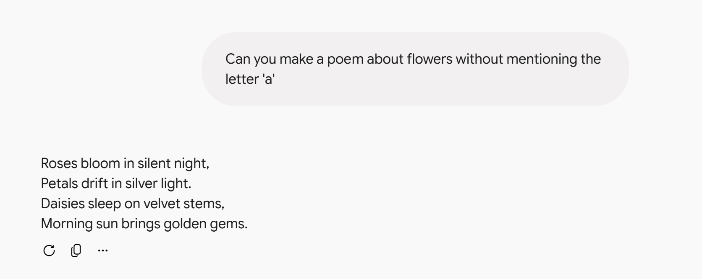
Write a reflection (half a page ≈250 words) answering the following questions:
1. What surprised you about the AI’s behavior?
I think in the case of the first question it went through a ‘list’ of desirable traits in humans that are seen as kind and compassionate and just ran with it to make me feel better about myself. I think for most questions that are seen as more ‘personal’ it tries to make you feel better about yourself which doesn’t always have to be a good thing. For the more ‘logical’ questions it always tried to give you a correct answer and then even go beyond the information you asked for and added extra information which also doesn’t always have to be a good thing. I think it’s however quite surprising that it is able to somewhat distinguish between what type of question you ask and adjust itself to the questions.

2. Where did it feel smart? Where did it feel dumb?
It felt quite dumb when I went for more personal questions since like I said above it tries to make you feel good about yourself instead of actually give advice or make a good guess. It felt smart when I asked for questions that I would consider hard for a normal person to just google like my prompt for question 3.

3. Would you trust this AI to make a decision for you? In which situations yes, in which situations not?
I would absolutely not trust this AI to make any moral or emotional decision for me; it does not have the capacity to feel these emotions and will not understand human relationships on the same level. I would however trust this AI to give me (mostly) accurate information on things that are easily accessible on the internet when I am too lazy to find it myself. Like who invented certain things or recipes for certain dishes.

